San Diego, California | June 27 - July 4, 2022 |  |  |  | NLC
Make it Count
Family, Career and Community Leaders of America
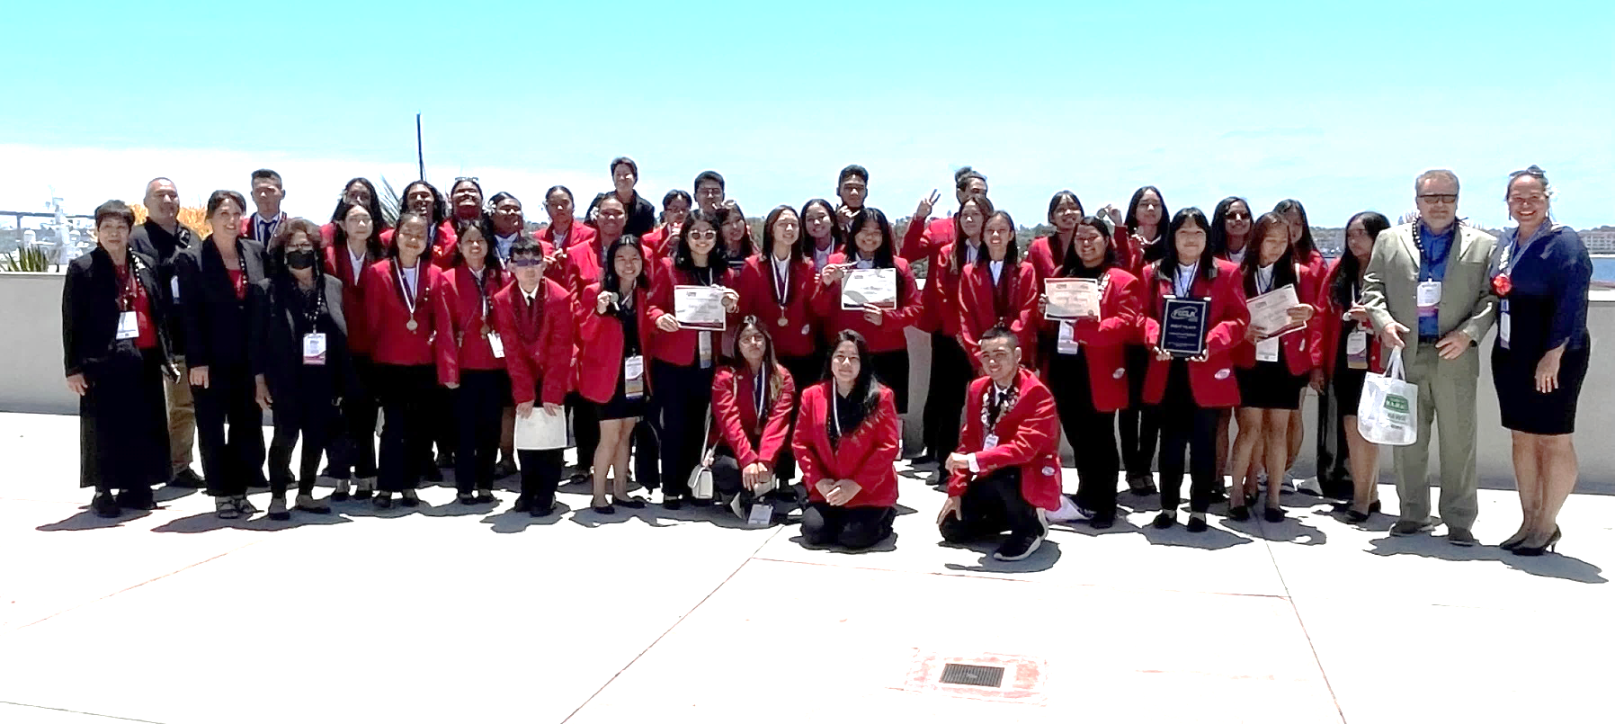
Career Development  Kahmee Teshima, Moanalua Chapter  FCCLA provides many leadership opportunities, such as becoming a chapter, state, or even a national officer. I was fortunate to serve as our chapter officer for three years and two years as a state officer. It was never easy, but it provided me with many character changing experiences; gaining the courage to speak in front of large crowds, learning to communicate with others, and developing better work habits.  Attending Nationals is never an easy challenge and it requires a lot of hard work and perseverance. However, it’s those who can push through that will gain the valuable skills for the real world. Working both individually, with a partner, and in a team allowed me to better understand skills I need to improve on for myself and how to better collaborate with others. I’ve also had the chance to participate in events that both matched my career goals or had nothing to do with it, but it was still a topic I found great interest in.  If you’re hesitant to join FCCLA because you don’t believe it will be beneficial towards your future career goals or you really do not understand what the club is about, I highly encourage you to take the risk and join. It’s through the hardships and challenges that you’ll come to understand what this amazing club has to offer, and I guarantee that you’ll look back and be thankful for the club. I am happy that I never quit this life changing club.  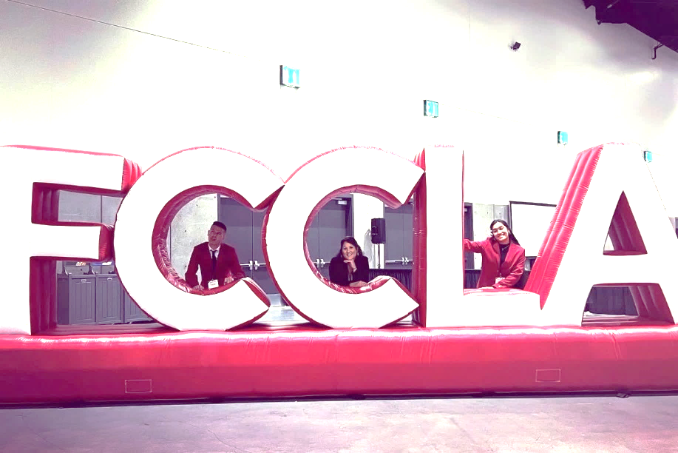 |  |  |  | A Mission  Sophia Cayetano, Farrington Chapter  During one of our networking sessions, we were questioned: “What is FCCLA to you?” As I am part of the program for only ten months and attended NLC for the very first time, I never really thought about it. I was just an oblivious girl who joined for the chance to volunteer in my community. However, as I sat quietly and listened to each of my fellow state officers’ stories, it altered the way I perceive FCCLA.  “FCCLA is more than just a program, it can help you forge a pathway for your life and broaden your understanding of the people and issues around you.” “FCCLA is family.” As I listened to how FCCLA had impacted them throughout the years, I was deeply moved to tears  by each of their stories. With most having to create lifelong friends and others having to experience new things they’ve never done before, it made me look back to my mission as a state officer: “to make our time at FCCLA a highlight in our lives that we will never forget.”  ‘Top Ten’  Kiara Agdeppa, Kapolei Chapter  Two days just before our STAR Event presentation, I had trouble memorizing my script and speaking without stuttering. It was so stressful, but after a few hours, I was able to make improvements until the night before presentation day, then I completely forgot my script! During presentation day, I was able to present my part well and with as much enthusiasm. All those hours practicing, all those times I had to reread my script really paid off. We made it to the top ten! Shaina and I were very proud and excited.  When the day finally came to announce the top three, we were very nervous. Shaking, fidgeting, and just hoping for the best. Third place, second place, and finally first place. “Kapolei High School, Hawaii” was announced and we were just frozen in place for a good second. We made it. Through this experience, placing first at nationals for our category “Nutrition and Wellness,” placing gold at national level, it helped me realize that our hard work really paid off. I was super proud of myself, my partner, those who have helped and guided us into reaching one of our biggest achievements. I am truly grateful to be part of this amazing journey, experience, and FCCLA.  Leaving the Islands  Elstan Simer, Waianae Chapter  Growing up, I never thought of leaving the island of Hawaii, to compete in a national conference. Exploring, making new friends, growing as an individual and as a team, this was my escape. This opportunity was a life changing experience for me, my achievement will never be forgotten.  Everyone was so excited to meet someone from Hawaii, and I felt the same way to be meeting 7,000 people from states across the nation. Everyone had different personalities, all were encouraging, and I was able to connect so quickly with strangers. We now followed each other on social media, that is the best relationship anyone could ask for when they are also your competitor in the same event.  This experience changed my view on how to approach and make conversation with others, a definite plus to help me in my future. Attending the conference, pin trading, and meeting other FCCLA students, was exciting; we were able to ‘hang out’ with our new friends as we were in the same hotel for a week!  This was an experience I will never forget and I want to encourage other students to attend NLC.  Competitions are Unpredictable  Kaitlyn Requillo, Farrington Chapter  For the first time in my life, at age 16, I placed gold at the 2022 FCCLA National Leadership conference. It is the highest accomplishment I have ever achieved, and the feeling is surreal. When we were told that we were being recognized on stage as a top 10 finalists, we were thrilled.  The night before our presentation, we presented for the first time to Mrs. Hatanaka and other chapter members. Their reaction was priceless, they were stunned and enjoyed our presentation especially when we sang our Old McDonald song. They also liked our ‘childish’ gestures that added character to our presentation. Their reactions calmed me down for our presentation the next day.  We never thought our project would be really successful. When we were competing at the state level, we really wanted to go to nationals so we put a lot of hard work into it. Whenever we felt worn out, the kids we taught were our motivation and kept us positive. The reason we did this project, is to expose children to the value of money. They pushed me to get creative. When you have ideas, make them come true and don't let others tell you otherwise.  Competitions are unpredictable so I try not to get my hopes too high but I still put in my best efforts as you never know how far it can take you. Standing on the stage, on the podium, smiling at the audience and the camera, and with the tremendous support, we felt surreal and overwhelming. Izah and I cried once we got off the stage.  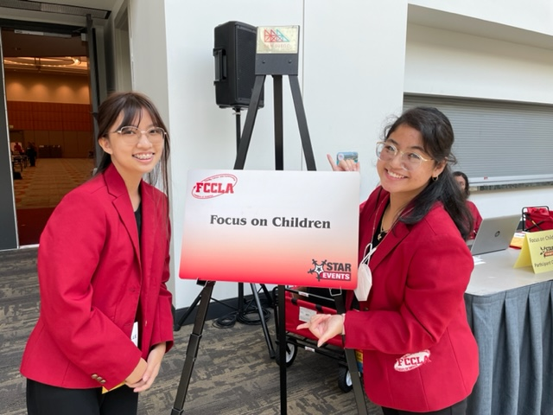  Picture Caption: To make your document look professionally produced, Word provides header, footer, cover page, and text box designs that complement each other.
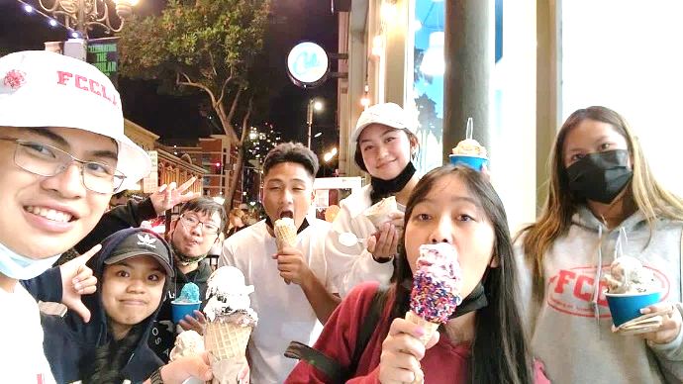

Becoming Great Friends
Sophia Cayetano, Farrington Chapter

Happiness, according to Angela Abraham, is “an absence of all negative emotions… the presence of any positive one.” This is how I felt when my roommates and I began to connect on a level we had never experienced before. Four girls from the same school hardly ever spoke to one another and were simply regular students passing each other in the hallways. I never imagined that going to San Diego for the NLC would change our relationship as we got to spend more time together sharing stories, making silly jokes, ‘vibing’ to music, playing games, and exploring the Historic Heart of SD late at night along with "the boys" from the room across the hall.

Laughter and smiles are all I can hear and see when I was with them. I believe that one of the finest moments I savored was strolling through the Gaslamp Quarter to purchase ice cream at Cali Cream three nights in a row. You can get 4 generous scoops of different flavors for just $5.50! With ice creams in our hands, glimmering pubs and restaurants all around us, and rental cargo bikes blasting music off to the side, we loved every moment as we walked through the empty blocked roads. Despite having the STAR Events we needed to prepare for, it
wasn’t on our minds as we were busy having fun and making each minute and each second of our time count.

During the trip, I was fortunate to meet and become great friends with two boys from another school in our state. The other two are from our school, and we girls collectively refer to them as “the boys.” I’m very happy to have encountered and interacted with every one of them. From strangers or acquaintances to close friends, they certainly made the trip worthwhile.
A Day at the Zoo
Daisy-Leilani Quidez, Farrington Chapter

Riding on the top of the bus was easier to see the animals, I love elephants and when I saw them it made my day. The air zipline was our next ride, as we were walking on the bridge I realize I could not do it, I have a fear of heights. When we sat in the ‘cart’ it started swinging, I panicked to the point I of hyperventilating. The air was cold, I started to cry, my legs were shaking, I held on to my roommates' arms. I’m upset because I let my fear interrupt with my experience. I can now say I rode the air zipline.
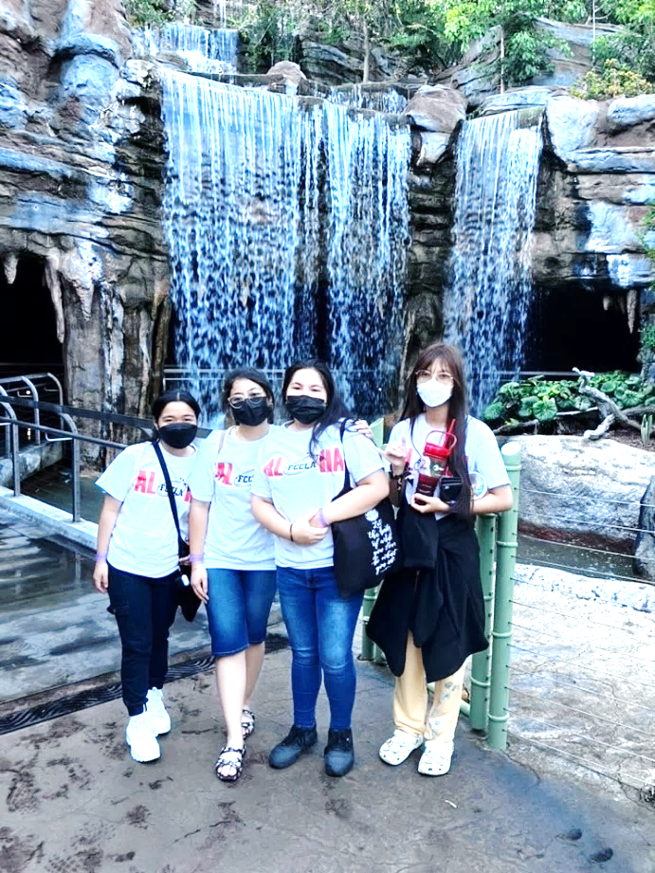

Amazing Bicycle Taxi Service
Kahmee Teshima, Moanalua Chapter

The city has these bicycle taxi services all around which will blast music from their carriages. There would be times where the taxis would be blasting a super fun song and I would make eye contact with the people getting pulled and jam out with them to the music. There was even a time I was talking to a fellow delegate about a funny million-dollar idea and some random guy just shouted back “I think you mean billion-dollar idea.”
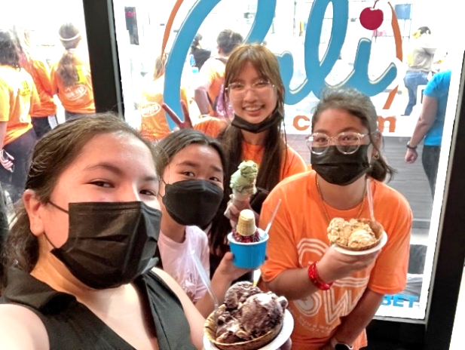

Exploring San Diego
Mark Angelo Orpilla Buccat,
Farrington Chapter

San Diego was quite an experience, it has been a while since I took a plane ride to the mainland. I am prone to motion sickness but am glad I was able to survive the plane ride without any accidents.

My roommates for the week in San Diego, were Cadyn from Farrington and Aris and Enson from Moanalua. I was shy at first but as the days went by, we became comfortable with each other, we went to places together, talked stories, created memories, and enjoyed having each other around.

We went to Sea World and the San Diego Zoo, it is nice to know that these animals are kept in enclosures for years and were safe and healthy.

Overall my trip to San Diego opened new opportunities and fascinating new places to visit allowing me to have an amazing time.

The Hop On, Hop Off Trolley
Izah Bragado, Farrington Chapter

The Old Town Trolley took us everywhere, we first arrived at Coronado to explore the Hotel Del Coronado with its famous and iconic history with celebrities and architecture. We walked around Orange Ave, found a place to eat, then found our way back to the Trolley. We visited Balboa Park with its magnificent buildings and museums. We past little Italy, and took a quick stop at Old Town State Historic Park with lots of Spanish merchandise-magnets, clothing, shells, toys, stickers and many more. This experience was new and cool!

STAR Event Evaluator
Daisy-Leilani Quidez, Farrington Chapter

Being an evaluator for “Career Investigation,” inspired me to compete in this event next year. As an evaluator, I became open-minded and interactive when speaking with other evaluators. I was skeptical about being an evaluator, as I heard it's boring, but I found it fun and interesting. I evaluated middle school students who were planning for their future. This made me think I should also start finalizing my plans for my future.

I found that volunteering helped me become a better version of myself. Take the opportunity and don’t miss it! I enjoyed being an evaluator and I got a ribbon to add to my name tag called “Star Event Evaluator.”

“Hi Nice to Meet You”
Elstan Simer, Waianae Chapter

“Hi nice to meet you! You want to trade pins and get to know each other?’ As I walked to my first national conference in San Diego, California, this was the sound echoing throughout the halls of the hotel and convention center.

At first I was a bit shy, but then everyone began coming to me and becoming their friend was easy. This is one, if not, the best feeling someone my age could feel while representing your state at the NLC.

New Experiences
Amanda Ibanez, Moanalua Chapter

While my friends were at SeaWorld or sleeping in, I was attending meetings. My meetings were early and I enjoyed them. I was able to meet new people as well as gain a deeper understanding of what goes on behind the scenes of the national election process as a nominating committee member. It was interesting to listen to the different candidates and it was surprising to learn that many actually remembered me as a national officer candidate from last year. It was fun to interact with people from different states, I really enjoyed being part of a committee that was full of such dedicated and amazing leaders.

I also was selected to host a workshop. This meant that I needed to prepare a thirty-minute workshop which was to be presented to a maximum of 80 people-no standing room-I was told. On the day of my workshop, I was overwhelmed; there were over a hundred people waiting for my workshop to begin. Setting up became stressful. A big thank you to Elstan, Jodecee, Enson, Tammy, and Ms. Perkins for helping me with setting everything up and helping throughout the entire workshop. I believe the audience had a fun time, they were engaged in constructing the origami decision maker.

These new experiences allowed me to further discover more about FCCLA, I definitely made the most of my time at NLC.

What FCCLA Can Do
Shayla Rarogal Mabuti, Farrington Chapter

Once I discovered what FCCLA can teach me, I became very much involved. First, I became my chapter’s Vice President of Fundraising and now the State President. I even made it to Nationals! This all happened in a span of 6 months. FCCLA has brought the leader out in me and has given me the drive in wanting to achieve more.

I could not have been more grateful for this life-changing experience. It has taught me so much about acceptance and finding similarities among differences with others. It has been the greatest experience of my life so far. I was given the opportunity to participate in breakout sessions, networking with FCCLA members from around the country, visiting the EXPO, taking part in competitive events, and my most favorite of all: trading state pins with others. There was a lot of pin trading and making new friends.

This was a wonderful experience for each of us as we renewed old friendships and gained new ones. I got to meet many students from across the country. I definitely had the ultimate leadership experience.

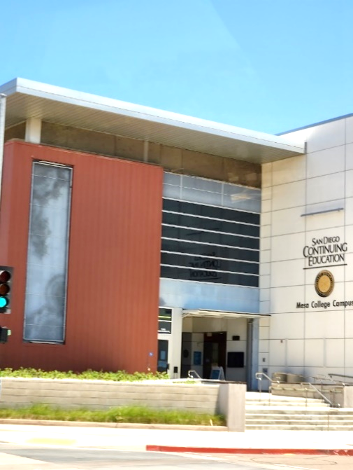  My Baking and Pastry Experience  Enson Miyakado, Moanalua Chapter  A very cold bus with black, felt chairs slowly took us to Mesa College, the site of the Baking and Pastry competition. No-one except the two Hawaii delegates were talking that entire 25 minute ride, so it was really awkward.  We were dropped off near the dumpsters, led to a two-sided elevator, then to a small balcony-waiting room. The kitchen was setup in an L-shape with the dish pit being to the right of the entrance and all the ingredients lined up in the connecting hallway of the main kitchen area. There were 14 tables in sets of twos, to help keep track of our time period. Six ovens were setup-three at 400°F and three at 350°F. I began at 1:30 pm with the other Hawaii delegate, Shannia. The college provided stand mixers with multiple bowls, attachments, spatulas, gloves, and towels, making it easier during my mise en place stage as I did not need to spend time taking out the equipment I brought.  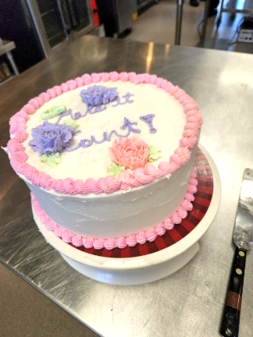  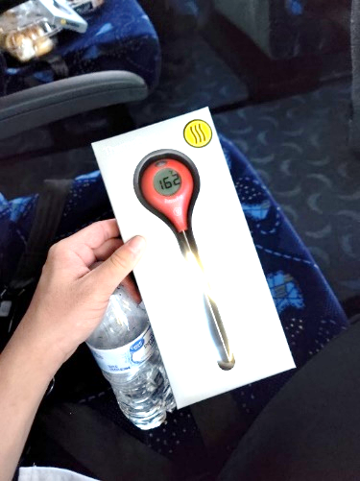  I started on my pate choux, got the cream puffs onto the pan, but I was too late, all the ovens within my reach were taken. This led me having all of my recipes done but no oven to bake them in. Also, I didn’t check my equipment beforehand-my stand mixer didn’t have any rivets to secure my bowl and that led me to spilling my muffin ingredients everywhere and stuck without a stand mixer for at least a good 8 minutes while one of the advisors helped to find the missing rivets. I did get all of the items into the oven and onto my serving pan, but due to the oven shortage, my workspace was full of unbaked stuff and I was forced to start on my cake with minimal space. My frosting flowers didn’t have enough time to ‘set’ in the fridge so my “cake” came out sloppy, but I finished. I then spent a good 45 minutes to an hour near the dish pit washing my dishes and the missing ones that some people just threw into a pile that I needed to dig out. That led to me missing the window to claim the food that I presented, and someone stole Mrs. Perkins measuring spoons from my workspace. But after all that turmoil and bad planning, I received a free meat thermometer from the college. |  | FCCLA Provides New Experiences  Angelica Ringor, Farrington Chapter  As a daughter of immigrant parents, I never had the opportunity to travel and explore different parts of the world. I’ve been on this island for 17 years, and have always dreamed about traveling to create new memories. On March 8, 2022 my partner Shayla Rarogal and I discovered that our Promote and Publicize FCCLA project received a gold medal. We had the opportunity to compete nationally. We were hesitant to travel outside of our tiny, isolated island, where everyone knows everybody, to another state - big and scary. In the end, with the encouragement from my parents, we made the decision to ‘travel.’  FCCLA had given us the experience of a lifetime by allowing us to travel to San Diego, California for a week to compete in the FCCLA National Leadership Conference. When we landed in San Diego, it became a reality, I couldn’t believe it, I had a wave of emotions flood through my mind, fear, excitement, etc… It was absolutely beautiful, the view from our hotel room was amazing, we saw the entire convention center.  The night before our presentation we tried our best to practice before we went to sleep, thanks to our support system, the people who believed we could do it, we got gold as well as the title of being in the top 10 in the entire nation!  Little did we know, how fun it would be to meet new people, visit different places, and gain new experiences. I now have two medals to hang on my wall, my achievements in FCCLA. I now have memories I never would have thought I would ever have, all thanks for choosing to ‘go for the red.’  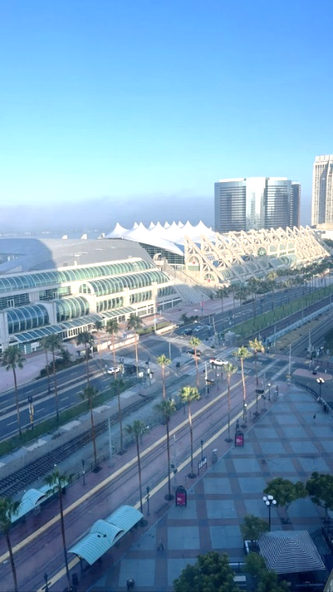  Our San Diego Zoo Excursion  Enson Miyakado, Moanalua Chapter  The excursion to the San Diego Zoo was a memorable experience for me as it was the first time that I remember being in California and the zoo. I was told that I have been to California, but I don’t remember much from childhood. It was unfortunate that we only had 5 hours to explore the zoo, but it was still a fun experience. We ran around to save time and see everything. I was with Aris-we got lost on the Hippo Trail but eventually we found the correct way out, putting us near the Arctic/Polar bear exhibit, where we took the skyline to get to the middle of the zoo.  We got a message from another member, so we rushed to get back onto the skyline and made our way back to the polar bear exhibit to pick them up. It was fun rushing around; we took many funny pictures of the exhibits as we made our way back to the right side of the zoo while cutting through a few other exhibits along the way. We checked in with our advisor ended our trip going to the giftshop right before they closed.  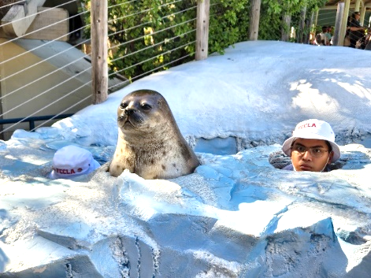  ‘Money Buddies’  Izah Bragado, Farrington Chapter  During the Spotlight on Projects event, we met many people and explained a few things about our project. We talked about the games we created and the money management children’s book, ‘Money Buddies,’ we wrote and illustrated. We also distributed play money with ‘Hawaii FCCLA’ stickers on it with additional information as souvenirs for those who came to visit.  Our STAR Event Presentation  Jace Lee, Moanalua Chapter  I still remember the day that of my competition, July 1. My teammates and I have been preparing for this day for months. I was nervous and stressed because I wanted to do well, as this would be my first and last National Leadership Conference.  As we entered the convention center, we saw many display boards with food, physical design models, and people dressed as chefs. I knew they were competing in, Food Innovation, our event. We check in, then the room consultant came to get us; as we walked toward the table, I could feel the tension in the room. The room was huge, even bigger than the ballroom where my prom was held. It was set up with tables in columns and rows, only a couple of inches apart from each other.  We quickly set up and was told to start whenever we were ready. We took off our masks and started presenting. I tried my best to present it the way we had been practicing, but stumbled here and there as I was very nervous and completely forgot most of the script even with my flashcards. I felt pressured as I presented because the judges and room consultants stared at me with the straightest face-I never felt more scared in my life. I was so scared that I was startled when the room consultant lifted the five-minute left sign even though I was warned about this. Once our presentation was over, I was glad they didn’t ask us too many questions.  We were unsure about our result, but we hoped to be among the top ten. Saturday morning, we got the news that we didn’t get to the top ten. It was sad. However, we were still hopeful of getting a gold medal. And WE DID IT! We did end up placing gold, and I have never been happier in my life to be able to get gold at my first and last national competition for FCCLA. This experience has made me proud of my accomplishments in FCCLA. From getting gold in our state competition to now getting gold in the national competition. All of our months of hard work finally paid off.
Spotlight Rewards
Kaitlyn Requillo, Farrington Chapter

On July 2, 2022, we participated in the Spotlight on Projects event, and it had a significant effect on me. I truly felt 100% proud of our efforts on our project. We worked hard, but when total strangers saw what we accomplished, it is really a heartwarming experience. We received an immense overflow of compliments from family, friends, FCCLA members and advisers; I couldn't help but break out in tears of joy.

Our project caught the attention of others, and a crowd was suddenly around our booth; we shared our project, they were instantly impressed. Some returned, bringing their friends. Words are not enough to express how grateful I am. The Spotlight on Projects event made me realize how kind people can be. We didn't have to give our 10-minute presentation for them to realize how hard we worked and cared about our project. The future is bright with leaders that encourages one another to take advantage of their full potential. Although I felt like the odd person out while entering the exhibit hall, because of my ethnicity and that our board was not as tall as everyone else's, but those who stopped by at our booth made us feel honored.
My Culinary Goals
Mark Angelo Orpilla Buccat, Farrington Chapter

FCCLA, without a doubt, has changed my perspective on myself. My advisors encouraged me to compete in a state culinary competition. As a junior at Farrington, I was skeptical about joining at first, but then I realized that this was the start of my journey to make my dream come true; becoming the best chef in the world. I’m able to create a future for myself by putting in the work and loving my work ethics to pursue my culinary career. My drive to become the best chef in the world has allowed me to achieve gold in my first culinary competition.

In San Diego, I was mentally and physically prepared to compete and win in my first national cooking competition, but I got knocked down. I felt that the sacrifices that I put in and the support that I received were a waste. My other classmates were able to win their national competitions either achieving top 10 in the nation or being number one in the nation. My pride was shot down, I felt ashamed, despair and utterly my head was down. Those feelings are still stuck with me to this day, I can never forget that feeling of trial and error.

It was a hard-felt loss, no matter how defeated I was, I went through it with my head high and chest out. I couldn’t be more grateful that I took the loss. When I look back, I can now see from a different perspective. I’ll keep striving, growing, and being relentless to get back to the national culinary competition. I have unfinished business. Until I win a national competition to prove that I’m highly capable of working at a high caliber, I will never be satisfied with representing my last name.
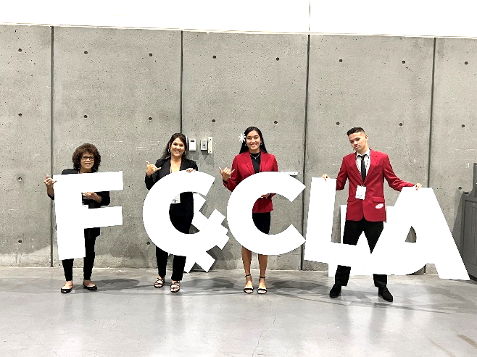

Our FCCLA Journey
Jodecee Jardine, Waianae Chapter

This FCCLA journey has been a memorable and overwhelming experience for me. From planning and executing our STAR Event, competing at States, and then traveling to San Diego, California for the first time. My chapter has come so far and our advisor, Ms. Keri Reese, has really challenged us as leaders to overcome challenges external and internal. At the same time, I’ve enjoyed my time with my group, state, advisor, and the FCCLA family. I can truly say that the year has been filled with great knowledge and memories that will last a lifetime.

Overall, my competition day was one of the best moments from the entire experience. We were scheduled to present to the national judges on Thursday, it went great! As I reflect from before our STAR Event presentation and afterwards, we really stepped it up. On that day, my partner and I were prepared yet we still had butterflies in our stomach. The feeling of the unexpected is nerve racking and we wanted the best for ourselves because we knew how hard we worked. As we walk out of the 20D ballroom, we gave each other big smiles and high fives. The relief I felt getting out of the ballroom was amazing that I cheered and got weird looks from everyone except from my advisors. They had big smiles on their faces.

We left it all on the table. We were pleased with how we presented our project and how we carried ourselves. I’m beyond proud of what we accomplished and traveling out of state to recognize what we’ve done. This was quite an experience for myself and actually getting the chance to travel with a friend where it was his first time to the mainland. Our team made this trip count!
Hard Work Paid Off
Shaina Laguatan, Kapolei Chapter

As a new member, I definitely had some doubts about this club and if I would be able to commit to this competition. I am so glad that my partner Kiara and I did not give up. Two weeks prior to the conference, we learned that we needed to do more research and ‘fix’ our project. We worked hard to get it done.
It was an honor representing Kapolei High Schoo in the Nutrition and Wellness event. Not only did we qualify for the Top 10 National Finalists, but we also placed 1st nationwide! I was honestly shocked when it was announced that we placed 1st for our category, all of our hard work really paid off.
A huge thank you goes out to my partner, Mr. Sampson, Ms. Sawai, and other mentors who helped make our project a success. They really pushed us to take on this challenge. Hopefully, I will be able to achieve something great again next year!
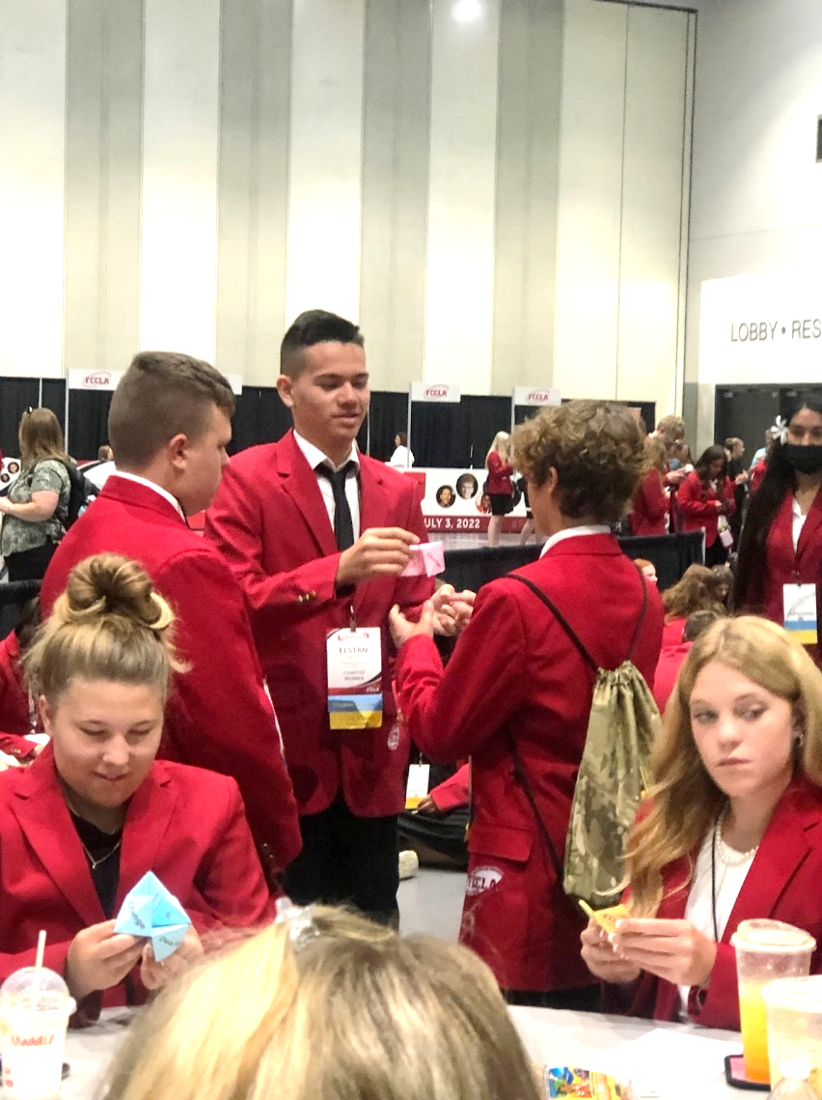

My Outgoing Partner
Jodecee Jardine, Waianae Chapter

I could not have asked for a better partner: Elstan Simer is a great student, leader, photographer, model, and friend! We became closer over the year in the Hospitality & Tourism class and FCCLA.

Elstan has never flown to the mainland before and being part of his first experience is an honor. I knew that he is an outgoing person, always wanting to do something and make the best out of his time in San Diego. He is a true explorer, I sometimes didn’t want to go, so he either went himself or with others; and that is who he is. A guy who can’t stay still and wants to go, go, go!

We are two different personalities in a group where we balanced each other. He is a friendly, sociable person, loves to learn and talk to others. I would have never made out-of-state friends if he wasn’t by my side. He has a welcoming smile that draws people to him – a magnet. But he also has some edge to him with his huge diamond rocks on his ears that everyone loved. Although he said he could never see himself in a suit, I think eventually he’ll be one of those guys wearing one all the time and adding a splash of ‘Guess’ to his fit.

I extremely enjoyed our time in San Diego, spending a whole week together, I saw a glimpse of how Elstan Simer lives and enjoys life!

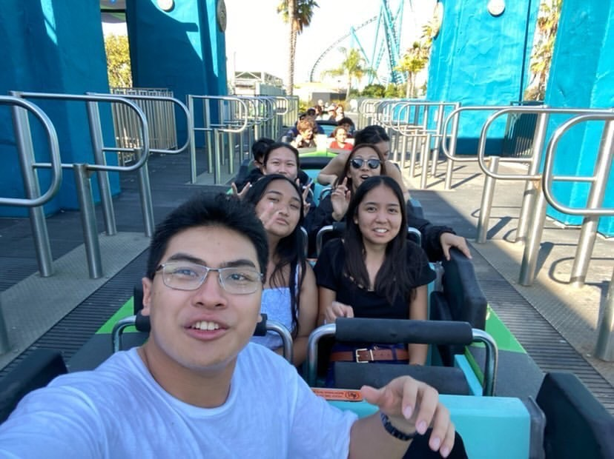  Sea World  Jace Lee, Moanalua Chapter  My most memorable moment from this trip was going to Sea World. As we entered, we could see the extreme rides. I was shocked and amazed to see these rides as they felt intimidating. There were many people there, and it was blazing hot. We first headed to one of the extreme rides called the Electric Eel, as we stood in line, all I could do was stare at how fast the ride was. It also had crazy loops and turns with a bunch of twists that were in 360° angles, almost like how a cinnamon twist looks. I could feel the butterflies in my stomach as the line got shorter and shorter. When it was our turn, we were given front-row seats, and the ride started without a countdown. I couldn't keep my eyes open for the majority of the ride. However, I could feel the adrenaline pumping in me from the extreme speed. It felt like nothing I have ever experienced, even better than the rides at the 50th State Fair in Hawaii. After the ride was over, we went to laugh at the pictures they took of us on the ride.  We then went to the different exhibits and watched the animal shows. One of my favorite exhibits was the shark exhibit, as we could see so many different sharks above and under the water. They had an underground tunnel and escalator under the shark's tank, so we were able to look and take pictures of the different sharks with their big sharp teeth.  We went to watch the orca and the dolphin show. I was thrilled and excited about the dolphin show as dolphins are my favorite ocean animals. I was not disappointed with the dolphin show, the dolphins jumped and played in the water to pop music. They splashed, spun around, giving the audience a fantastic show. I was in love with their cuteness and their playfulness.  We went on the Journey to Atlantis, where we stood in line for two hours to get on! This ride took our boat up in an elevator one at a time, it was scary--then there were loops, turns, and another massive drop at the end. However, the ride that got my heart pumping was the fastest roller coaster ride in San Diego SeaWorld, called The Emperor. The ride goes sixty-plus miles an hour from a huge steep drop and into loops and curved turns. I was so scared, but it was so much fun because I had never felt the tremendous amount of wind in my face. Not only that, but the speed on this ride was nothing you would ever experience. We ended our Sea World Experience with an Adrenaline and laser night show, and we finally returned to our hotel room at 9:30 pm.  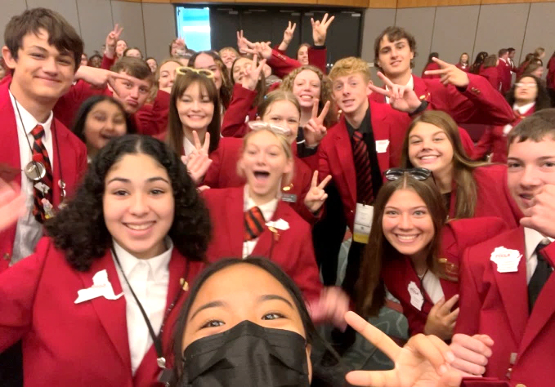  Sustainability Challenge  Rachelle Anne Manuel, Farrington Chapter  Becoming a FCCLA member has changed my life and my perspective in so many ways. At the beginning of the school year, I was put to the task of creating an environmental project called “Sustainability Challenge.” My partner and I created a self-watering planter that included recyclables such as plastic water bottles and wipes. The self-watering planter also helps with water usages; not using too much or too little water for the plant. We put the self-watering planter to the test and in a couple of days, a plant started to sprout.  We conducted classroom presentations which taught future generations the importance of repurposing recyclables, wasting less water, and growing your own foods. In the process of preparing our project to present to high school classes, we were able to stand in a teacher's shoes and understand how hard teaching is. During our first presentation, we learned many things we needed to improve on including projection and being more prepared, so our presentation runs smoothly. After a few more presentations, we were able to improve on our speaking skills and run our presentations smoothly. We practiced projecting our voices and learned more ways of getting students' attention. By doing all these classroom presentations, we were able to share how to be more sustainable while improving our teaching skills. Although I went through many challenges and faced many obstacles along the way, it was worth all my accomplishments. I am proud that I put in many months of hard work creating a whole project and presenting it to several high school classes. I was able to achieve a gold medal for both states and nationals! This not only benefited myself but also others around me including the environment. By teaching the next generation about sustainability, we could all learn and enforce sustainability practices to our environment and give back to Earth.  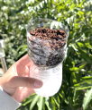  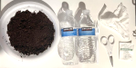  Life Skills through STAR Events  Izah Bragado, Farrington Chapter  Grit and perseverance; a life skill that can be overlooked but played a key role in creating our project, ‘Let’s Talk Money. We made many sacrifices within our lives  Critical decision making skills, especially through sacrifices. Lots of time was spent and it was dreadful at first, but we learned and made progress.  Collaboration and effective communication skills are important as it requires trust and authenticity. Knowing how to distribute and manage our tasks; Kaitlyn is very good with her words while I am very artistic. We worked in areas that we work best, but also helped out when we need it. This was shown through making our Money Buddies money management children’s book. Kaitlyn was the author and I was the illustrator, both of us were able to bounce ideas to each other to make it as best as possible.  The reward: States and Nationals. Winning a gold medal in states means you are able to go compete in Nationals. If you are committed enough, you will be able to fly out of state like me! This year it was a week in San Diego, California.  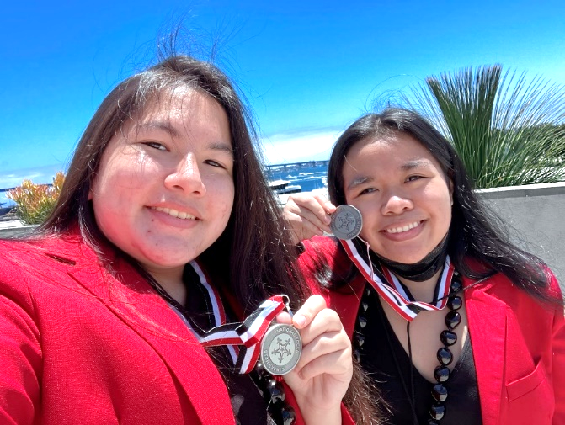  Silver has Worth  Cherie Kong, Farrington Chapter  Silver, a shiny grayish-white metal, the chemical element of atomic number 47. A distinguished color that symbolizes wealth, success and can represent clarity as well as strength.  Success is something I desired to have on this trip to San Diego National FCCLA competition and going home with a silver medal suffices that.  It all happened in a room filled with other competitors in the many different categories, Hawai’i, Mississippi and Louisiana competitors were receiving their awards. There were about five rows of Star Event competitors, all waiting for the Recognition Session to begin.  Names, categories and medals were being called out. Mississippi’s Vice President called “National Programs in Action ..… Cherie Kong and Daisy-Leilani Quidez ….. silver.” There was a pause before her words finally processed, we got silver. A wave of relief washed over but also disappointment came over me. Relief that we placed and it was not a bronze but disappointed that it was not a gold. As we both walked to collect our awards I thought “All that and getting silver,” another few paces “we did good, what went wrong?” My hands clammed up a bit with the number of possibilities running around. “Did I do something wrong that got us deducted points to win silver?” “What was it?”  As I made my way to the front I saw Shayla - State President of Hawai’i. She was nervous, anybody who knew her could tell, but putting that aside she voiced out a sincere congratulations and presented our silver medals. Having her congratulate me with such a kind voice made me a bit happier about my placement. With the medal around my neck, the decision was final, silver. I appreciated getting silver and I’m glad that we had placed second but when you have been striving for gold there’s always that sliver of dissatisfaction.  Throughout the day all of us were being congratulated I was moderately dispirited. Not because I think we didn’t do enough, because I felt like I let people down. A lot of people expected me to come back with gold since their expectations were so high, that anything not gold wasn’t worthy.  When I got back to my room, it dawned on me that silver has worth and it wasn’t only about winning. As my mind cleared up, it turned to pride. How many people can say they went to a state then national competition to stand up for a cause they believed in? Not many. Although I got silver, my dissatisfaction did not even compare to the pride I felt. I had the courage to step out of my comfort zone and advocate to better the lives of my community. (The challenges of being a teen parent)  This is my story of standing up for change no matter the outcome. Because all in all, it beats not saying or doing anything and most importantly every little thing has worth, even the chemical element of atomic number 47. Thank you to my advisor, chapter, professors, social workers and my team for supporting me throughout this journey.  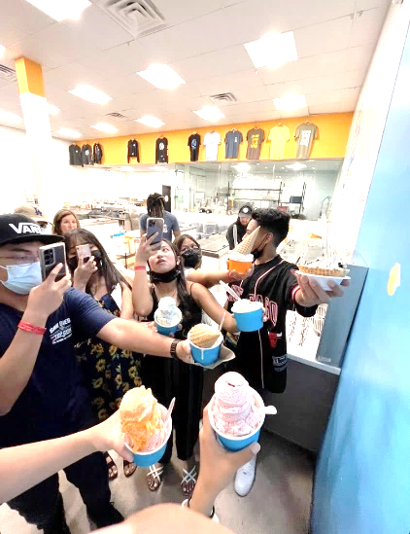  A Visit to San Diego  Shayla Rarogal Mabuti, Farrington Chapter  San Diego is the city that guarantees fun for both children and adults, and my experience during my stay just proves it! Make sure to explore the Gaslamp Quarter, the lively epicenter of San Diego's Downtown. The Gaslamp Quarter is famous for nightlife and entertainment. This part of San Diego is also listed as a historic district. I happened to pass by The Artisan Market. It reminded me of the Swap Meet in Hawaii. The Artisan Market takes place every weekend. There are tents full of food, craft goods, and other neat stuff that you probably will not be able to find anywhere else. This is definitely the place to go shopping for Christmas gifts and awesome art to hang on your wall. The Gaslamp Quarter really had good restaurants, entertainment, and shopping for tourists and locals. We were so awestruck when we visited it.  Cali Cream is such a wonderful ice cream shop! I tried the Blueberry Cheesecake, Oreo Dough, Birthday Cake, & Salted Caramel Truffle. The ice cream is creamy, soft and delicious, with tons of flavors. Great customer service, and a pretty good deal for under $6. I highly recommend it, as it was the best ice cream we have ever had!  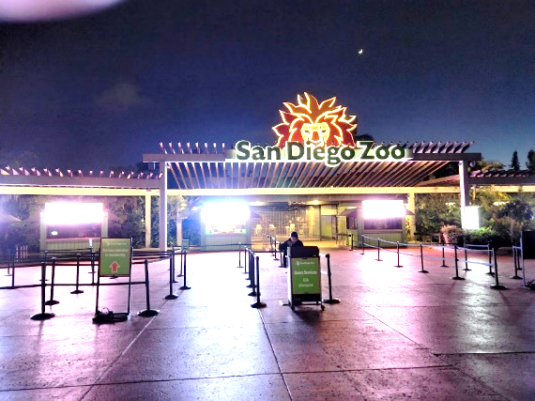  A visit to the San Diego Zoo is also another fun day. I got to discover thousands of wild animals including penguins, koalas, pandas, elephants, and even polar bears. I highly recommend taking a ride on the Skyfari aerial tram. Make sure to grab your camera and take lots of pictures with your friends and families. | Focus on Children  Izah Bragado, Farrington Chapter  We checked in 30 minutes early for our event, and they were ready for us. It was nerve racking at first, but once we got into the zone, it came naturally. The presentation wasn’t perfect, but it went well with high praises.  We learned that we were in the top 10 of our category! Kaitlyn and I were overwhelmed with the amount of support for our project. I honestly felt like breaking and crying so many times. When we were finally on stage with crowds of people looking at us, everything was going so fast! Then I heard ‘Farrington 1st place,’ Kaitlyn and I walked over to the middle and posed with our 1st place prize. We cried when we got off stage. All I could do was smile and happily tell my parents that Kaitlyn and I got 1st place for our project! It was finally over, and I enjoyed every moment of it.  Snapshots:  Kahmee Teshima, Moanalua Chapter  Over the past 4 years, I’ve been able to learn a wide variety of soft skills as well as more about different careers that I didn’t have a large interest in.  Sophia Cayetano, Farrington Chapter  Many of the state officers have been members for more than three years, they are like a family, they scream their state chants proudly and confidently, I questioned myself: “how can we make our members be like theirs?” This is something I hope to achieve for this year as Hawaii’s state first Vice President.  Enson Miyakado, Moanalua Chapter  I really enjoyed the trip in general as I was able to interact with more friendly people than I usually would, working front of house. It was fun trading pins with other states  Late Night Ice Cream  Cherie Kong, Farrington Chapter  It was quite a chilly night on June 30th when my roommates and I ventured out of our hotel. Telling our advisor about heading out before walking into the streets of Gaslamp Quarter. The streets were lively, the restaurants and bars filled with people enjoying themselves. We too wanted to enjoy ourselves, being high schoolers so we went to get ice cream. As we walked, one side of the street you could hear music and loud laughter, lights were strung along the fences outlining the area giving it that nice energy. We also saw a bike carriage blasting some hip hop with wild passengers-another carriage was the exact opposite, it played classical music.  We made our way to Cali Cream, about a ten minute walk through Gaslamp Center, There was a line out the door as we arrived, we took our time to read the menu, it was extensive. We laughed at a few flavor titles, like “Faddy Daddy”, a tongue twister of a flavor “Whatchamacali” and even an alcoholic one “Purple Dinosaur”. We ordered, a green tea ice cream in a cone for Izah, a control dandy fizz ice cream in a chocolate sprinkle bowl for Daisy, a Kona coffee chocolate chip I cream in a waffle bowl for Kaitlyn and finally a rocky road in a waffle bowl for me.  To think about it is kind of mind blowing not because I’m eating ice cream well it is a part but the fact that I’m attending the National Leadership Conference in San Diego, California an achievement and a place I never thought I would be in. If someone told me a year ago that I would be walking down San Diego streets with these three girls because I participated in competing for my program I would have laughed, it is just unbelievable how far we had came.  Participate in STAR Events  Izah Bragado , Farrington Chapter  Kaitlyn and I placed 1st nationally in the Focus on Children category, we stood on the podium proudly as we held the plaque with smiling faces. FCCLA is a student organization that’s related to Family and Consumer Sciences Education. Student Taking Action with Recognition, is one of the competitions directed by FCCLA with over 30 categories for members to choose from. Competing in STAR Events gives students the opportunity to develop and flourish their interest, which will deeply impact themselves and their future with fundamental life skills.  *Grit and perseverance - to be committed to your project and to strive for the best. *Communication skills to achieve effective collaboration.  *Reward and benefits, to look back at what you have achieved.  Competing in STAR Events helps you to develop yourself into a better person. You are able to use your experience on your resume. It’s time to consider joining FCCLA to compete in STAR Events because it’s something you can’t miss. Learn with your passion and bring a positive change. What I truly got out from competing this year was to ‘make it count’ and will be one of the things you will never regret, participate in this unforgettable opportunity.  Fundraising  Izah Bragado, Farrington Chapter  A huge thank you to those that donated to us and as well as the FACF for their immense support! Thank you to our advisors who worked hard to dedicate their free time organizing the trip! Without their help, funding the trip would have been even harder. July 27, 2022 my final day on Oahu, all my things were packed and I had to say goodbye. It was terrifying going inside the airport by myself, but I wasn’t alone, I saw others with the red shirts!  A Great Opportunity  Izah Bragado, Farrington Chapter  It was fascinating and fun trying to spot things that we do not have on Oahu, such as trains and less busy roads. I stayed in the Omni Hotel with the best roommates. I highly recommend to not miss this opportunity and the experience of flying out of state, because next year will be in Denver, Colorado! I ate a variety of foods, went shopping for souvenirs, experienced cool new places, culture and history. It was expensive, but as long as you work hard trying to fundraise it makes it all worth it. It’s a once in a lifetime opportunity, so take advantage of it!  Snapshots!  Mark Buccat, Farrington Chapter: Hawaii is a melting pot of diversity which is my experience, so it was interesting to meet others, mostly Caucasians.  Izah Bragado, Farrington Chapter: Kaitlyn and I participated in the Run for Red, we ran 4 miles with Mark and Sophia. The view was stunning and would definitely recommend running again. After a tired workout, my roommates and I went to get ice cream!

A Flight Like No Other  Cherie Kong, Farrington Chapter  The route of this flight was from Daniel K. Inouye International Airport to the San Diego International Airport. This was a huge step for me as it would be my first trip to the mainland. It felt so unreal getting onto the plane, it was a finalization that we were all going to the FCCLA National Leadership Conference.  We enjoyed how the sky changed from light blue to an orange tint that seeped into unique colours. We kept ourselves occupied with my deck of SpongeBob Meme Uno cards, eating snacks and, even dedicating time to practice our scripts.  I gripped the arm rest of my seat when the plane’s wheels ejected from its compartment and made a bumpy but safe landing. It took me a moment to calm down. We waited until majority of the passengers were out before getting our bags from the overhead bins. As we walked off, it seemed like in the movies where the main character is starting a new chapter of their life and in a way I was too. I was never a member of FCCLA, so I have never completed this competition before so I had no idea what to expect. Just like the main characters in the movies.  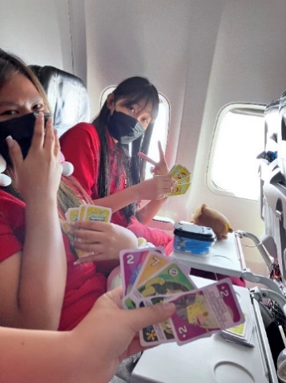  My journey to the NLC started as soon as I got off the plane and it wouldn’t have been possible without our advisors, members, professors, social workers and all the donators that made it possible for us to be able to achieve these milestones. I wanted to soak in all the hard work that got us here and all the philanthropists who had faith in us by giving their knowledge, skills, time and financial assets so that we could get to this point in our lives. | The Hotel View  Izah Bragado, Farrington Chapter  It was late at night and I finally arrived in San Diego! The flight went smoothly. I got my suitcase and hopped on a van to the Omni Hotel. I still couldn’t believe that I was in San Diego. The streets were partially empty, trains past by and there were city lights everywhere. We passed through multiple boats and fancy looking restaurants; I just knew that my savings was going to take a huge financial hit after this trip. As I waited for my key card for my room, I noticed that the hotel was lavish and grand. When we entered our room we were in awed and stunned by the great view. We could see the convention center, where the National Conference was to take place, the design was unique as if it were in waves and majority of it was built of glass.  Join FCCLA!  Shaina Laguatan, Kapolei Chapter  The FCCLA National Leadership Conference held in San Diego was such a wonderful, fun experience, and I will never forget it! Traveling to different places in San Diego with my fellow chapter members and advisers was also a huge bonding experience; they were like a second family to me. I would like to encourage everyone to join FCCLA and attend the NLC! |  | Spotlight on Projects  Kahmee Teshima, Moanalua Chapter  Some moments that really stood out for me was when I spoke to advisers and members during the ‘Spotlight on Projects’ session. Many of them were fascinated by our project and some even thanked us for utilizing ‘Vietnamese Bahn Mi as it made them feel like the Vietnamese community was being represented. There were also a lot of advisers who were intrigued by our project and felt like it was unique as compared to the typical ‘Food Innovation’ projects. Many advisers asked us if we made it into the Top 10 and were shocked when we said we did not. However, these same advisers still shared encouraging words and even brought their younger students to our board to show them what they can do when they reach our age. Those little interactions helped me realize that just because we didn’t win a specific title doesn’t mean that we failed. Hard work pays off in any way you define success.  Kind vs Strict  Elstan Simer, Waianae Chapter  Reading my results from the state competition, I was so impressed for how we did and also how much work we did to complete this project. But with the comments from nationals, it wasn’t the outcome we expected. When students attempt to exceed more, they want the outcome to be better than they expect.  From personal experience, I feel that when students compete at the state level, they should receive feedback and results in a very strict way. When receiving harsh feedback students may improve faster. Which is a way for them to know what to work on instead of getting their feedback after nationals from their results.
Breaking news
The latest local news

-------------- MIRJAM NILSSON

Video provides a powerful way to help you prove your point. When you click Online Video, you can paste in the embed code for the video you want to add. You can also type a
“Video provides
a powerful way to
help you prove
your point.”
Save time in Word with new buttons that show up where you need them. To change the way a picture fits in your document, click it and a button for layout options appears next to it. When you work on a table, click where you want to add a row or a column, and then click the plus sign.

